**LAB REPORT NO 10**



**CSE-206L Electronic Circuits Lab**

Submitted by:  **Muhammad Ali**

Registration No: - **19PWCSE1801**

Class Section: A

“On my honor, as student of University of Engineering and Technology, I have neither given nor received unauthorized assistance on this academic work.”

Submitted to:

**Engr. Abdullah Hamid**

Data:(15,07,2021)

Department of Computer Systems Engineering

University of Engineering and Technology, Peshawar

**For 2N3904: -**

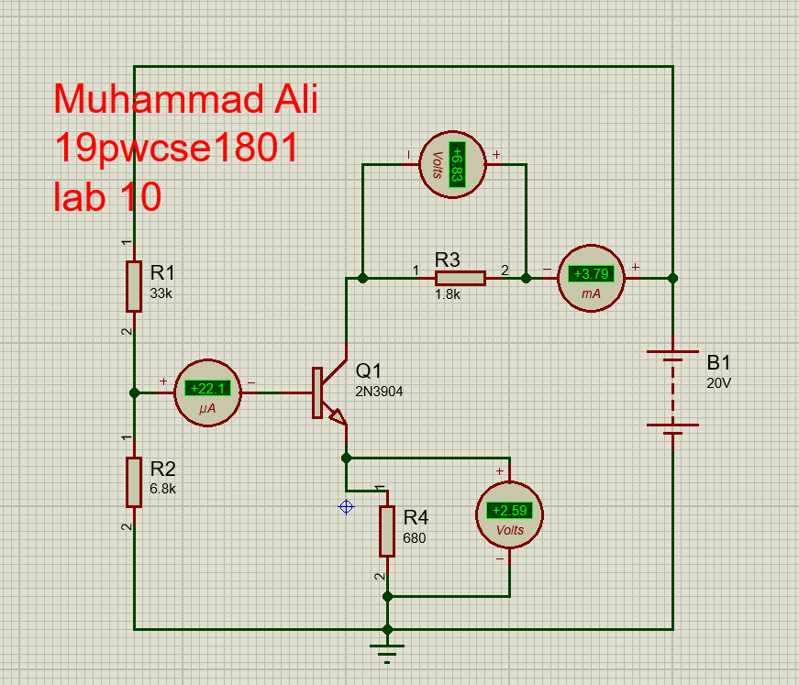

**For 2N2222: -**

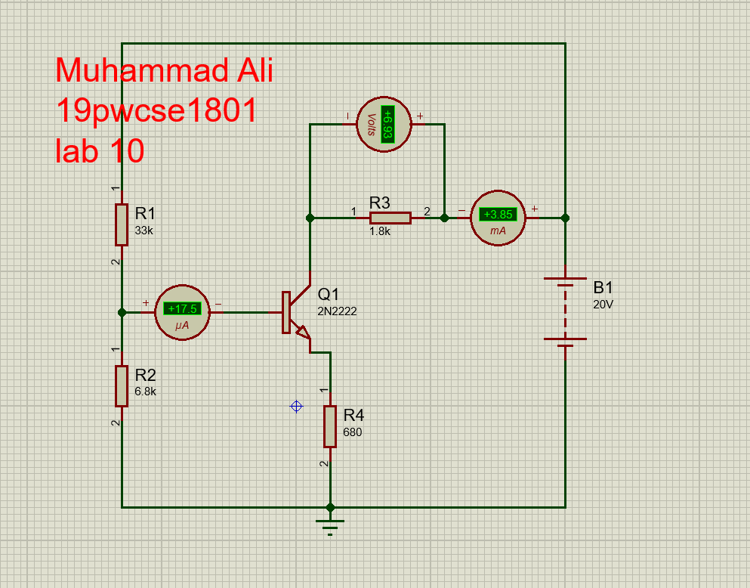

**Reading: -**

|  |  |  |  |  |
| --- | --- | --- | --- | --- |
| **Transistor** | **IB** | **IC** | **Beta** | **VCE** |
| **2N3904** | 22.1µA | 3.7mA | 167.7 | 13.18 |
| **2N2222** | 17.5µA | 3.82mA | 220 | 13.07 |

**Calculation: -**

**For 2N3904: -**

**To find VCE: -**

VCE = VCC – VRC

VCE = VCC – ICRC

VCE = VCC – IC (RC +RE)

PUTTING VALUES

VCE = 20 – 3.7mA(1.8*1000)

VCE = 20 – 6.82

VCE = 13.18

And,

**To find Beta, β: -**

Beta, β =IC /IB

Putting values

Beta, β =3.7mA/22.1µA

Beta, β =167.4

**For 2N222: -**

**To find VCE: -**

VCE = VCC – VRC

VCE = VCC – ICRC

VCE = VCC – IC (RC +RE)

PUTTING VALUES

VCE = 20 – 3.85mA(1.8*1000+680)

VCE = 20 – 9.54

VCE = 10.5

And,

**To find Beta, β: -**

Beta, β =IC /IB

Putting values

Beta, β =3.85mA/17.5µA

Beta, β =220

**To find Change in beta, β: -**

Change in beta, β = | (β2N3902 – β2N222) |*100/ β3902

Putting values

Change in beta, β = | (167.4 – 220) |*100/ 167.4

Change in beta, β = 5230/ 167.7

**Change in beta, β =31.18%**